IMHA two-year report

Purpose
On 31 August 2017 IMHA turned two. The following is a summary of the service’s achievements, reflections and examples demonstrating individual and systemic advocacy work.

Achievements
In its second year of operation IMHA focussed on consolidating and embedding the work done during year one. This has included continuing to provide services to consumers via a phone line staffed by advocates and delivering services in inpatient units across the state; building on relationships already established with designated mental health services, mental health support services, consumer led organisations, Office of the Public Advocate, Mental Health Complaints Commissioner and other services; promoting the service; and providing education regarding supported decision making by trialling a train-the-trainer model with Monash Health.
Building on the success of its first year, IMHA has continued to co-produce consumer information with an external consumer consultant and our consumer advisory group Speaking From Experience (SFE), including Advance Statement and Nominated Persons Guides and Templates. IMHA staff across the state are also involved in a range of systemic advocacy activities including raising awareness about practices and trends within services with the Department of Health and Human Services; attendance at consumer advisory groups; delivering training to support capacity building across the mental health system; participation in committees and advisory groups; contributing to Victoria Legal Aid policy and law reform submissions; and research.
In January 2017 IMHA introduced a consumer survey provided to all consumers we work with and accessible on the website, measuring consumer satisfaction and impact. 41 consumer surveys were returned to IMHA from January to December 2017.
Most consumers reported that they strongly agreed that:
- their IMHA advocate had listened to them, treated them with respect and supported them to communicate their views and preferences.
- their IMHA advocate effectively communicated with the treating team about their views and preferences, provided helpful information and linked them with helpful services.
- they had a greater understanding of their rights and were more confident expressing their views and preferences to their treating team.
- they had a better understanding of the mental health system and felt more involved in decisions regarding their treatment and recovery.

Consumer feedback
Consumers continue to provide IMHA with feedback about their experience with the service. Throughout this report are just a selection of quotes consumers have shared with us:
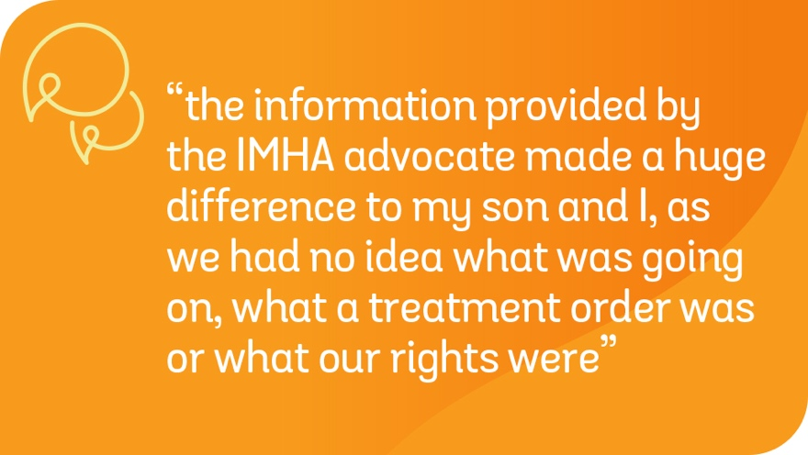
The Speaking From Experience consumer advisory group continues to meet and contribute to the work of IMHA and Victoria Legal Aid. In the last year they have worked closely with IMHA to develop consumer information, presented Advance Statement and Nominated Persons information that will be available on the website and social media channels as a video, and informed the external evaluation of IMHA.

External evaluation
In May 2017 RMIT was appointed to undertake an external evaluation of IMHA’s efficiency, effectiveness and sustainability. The midterm review has now concluded and was overwhelmingly positive, with all stakeholders giving positive feedback.
“The central tenet of IMHA’s service – rights-based representational advocacy – was consistently portrayed by the staff and valued by consumers”.
The evaluation is due to conclude in November 2018 and the midterm and final findings will be accessible on the IMHA website.

A summary of our work
Below is a snapshot of IMHAs Year One and Year Two achievements and information about consumers who accessed services.

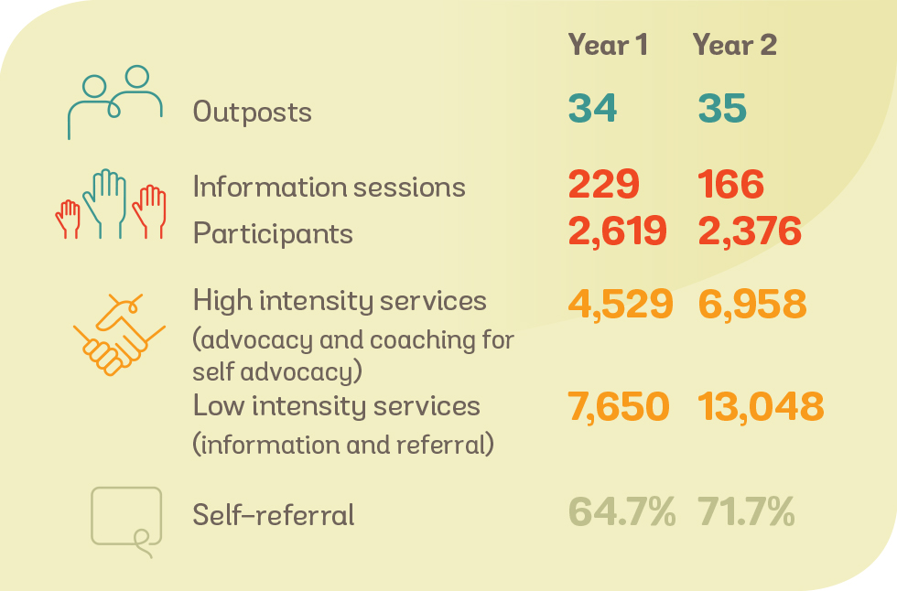
The following graphic provides demographic information about the consumers we provided advocacy and self-advocacy services to in the first and second year. It does not include consumers for whom we provided information and referral only due to limited data collected.

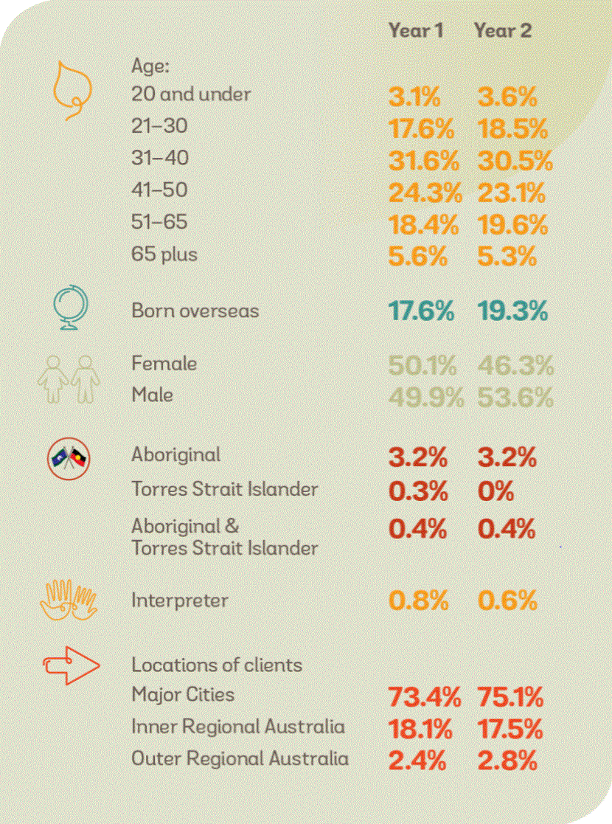
This year IMHA provided services to consumers who identified a range of concerns. The following table lists the most common issues raised by consumers that advocates provided assistance with, including information, coaching for self-advocacy, advocacy and referral
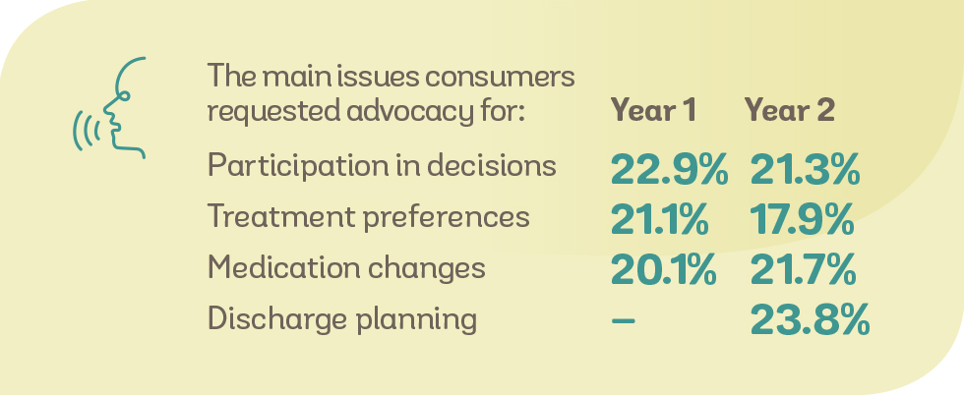
The following table ranks the number of consumers who have received Advocacy services within Designated Mental Health Services (DMHS) in Year One and Year Two. This data does not include consumers who contact IMHA and only receive assistance by telephone. The table below demonstrates increases in the number of consumers we have worked with in Year Two.

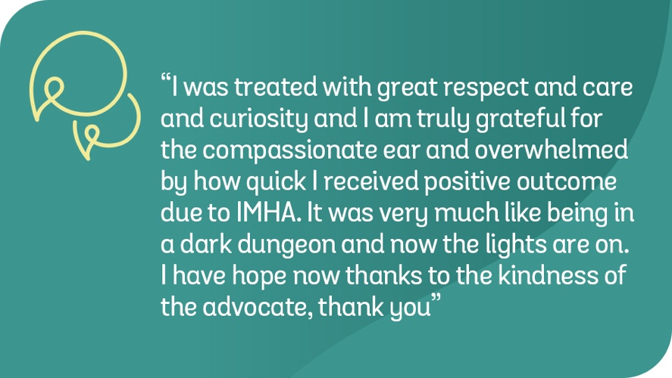

Reflections from our first two years in Designated Mental Health Services
The following are some of the trends that have been identified by IMHA advocates over the first and second year of service provision. IMHA will continue to record issues and raise these with individual DMHS as well as with other relevant stakeholders, i.e. Office of the Chief Psychiatrist and the Department of Health & Human Services (DHHS). The trends have remained similar in Year One and Two.
Themes identified during the provision of individual advocacy:
- Responses to family violence, sexual assault and childhood trauma in some services do not align with good practice as detailed in the Department’s Service Guideline on Gender Sensitivity and Safety and Guide on Identifying and Responding to Family Violence. For example, several consumers have told IMHA advocates they felt disclosures have been dismissed as part of their illness; some services have contacted perpetrators of violence to share information about the consumer despite the consumer’s disclosure of violence and explicit request that perpetrators are not contacted and involved in their care; and some consumers have had access to specialist services refused, i.e. sexual assault counsellors. Worryingly, several women have disclosed being discharged to housing where they will be unsafe due to family violence.
- Consumers often state that they do not know what Order they have been placed on, nor do they know what their rights are. This suggests consumers are not receiving copies of compulsory treatment orders and that rights information is not provided in a way that supports consumers to understand it.
- Supported Decision Making does not appear to be the most commonly used model across services, with Substituted and/or Shared (Collaborative) Decision Making being observed by Advocates as the most frequently used decision-making models. Indeed, most consumers requesting advocacy from IMHA are concerned they are not actively involved in their treatment, discharge planning, risk assessment or recovery, i.e. leave denied or restricted without the consumer’s involvement in decision making.
- Consumers’ physical health needs are often not addressed in a timely manner, for example, consumers are waiting for lengthy periods of time to see specialists.
- There appears to be a lack of access to talk therapies that may be preferred by consumers and a reliance on medication as the primary treatment modality.

How we make a difference
The following examples have been provided by IMHA Advocates to demonstrate some of the work involved in providing advocacy services to consumers subject to compulsory treatment.

Help to influence treatment and discharge decisions
A 49-year-old woman born overseas contacted an IMHA advocate at an Acute Inpatient Unit after the advocate gave a regular information session in the Unit. While living alone in her own home the woman had been placed on a Temporary Treatment Inpatient Order and was seeking information about her rights regarding discharge. She expressed concerns about changes being made to her medication without consultation and was frustrated that her requests to meet with her psychiatrist to discuss medication options were not being responded to. Additionally, the woman had concerns that staff were recording that she was “refusing medication” and were seeking to involve her family in decisions about her treatment, against her wishes.
Service provided and outcomes
- Coaching to Self-Advocate – Outline of the mental health system and coaching for self-advocacy by advocate, using IMHA’s “Know Your Rights” brochure.
- Information – Outline of supported decision-making tools such as making an Advance Statement and how to appoint a Nominated Person. Discussed the treatment criteria associated with compulsory treatment orders, role of the mental health tribunal and how to seek revocation of a treatment order, right to seek legal advice and/or representation.
- Outcomes – The Consumer met with her psychiatrist and self-advocated. She used IMHAs "Know Your Rights" fact sheet and advocated that she had time to talk to her doctor about medications and to be discharged to enable less restrictive treatment in the community. The consumer said her doctor agreed this was reasonable and acknowledged the consumer’s rights to influence her treatment. The consumer was discharged on the same day.
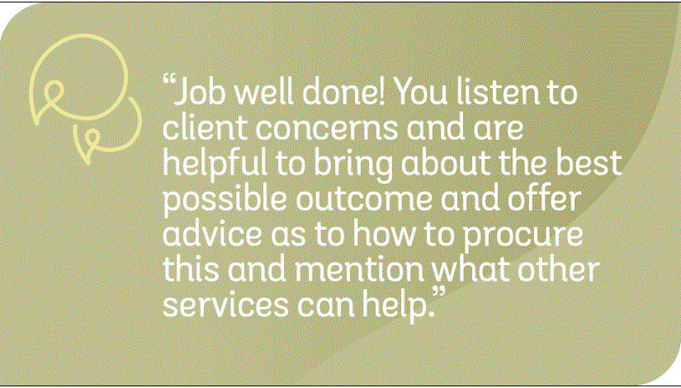

Assisting to cease unwanted treatment
A 51-year-old Australian born woman contacted IMHA after another consumer in the inpatient unit told her about the service. The woman had been on an Inpatient Treatment Order for a few weeks and was concurrently experiencing complex physical health issues. She was seeking help to stop upcoming sessions of Electroconvulsive therapy (ECT) as she already had undergone several sessions and was scheduled for more. The sessions had been ordered by the Mental Health Tribunal, however she felt she did not require any more and was distressed by the side effects of ECT including significant memory and cognition problems, concerns about the impact on her veins as they were compromised from pre-existing health conditions, and significant headaches. The woman’s preference was to stop doing ECT.
Service provided and outcomes
- Information– The advocate provided the woman with information about ECT and the guidelines that, even if ordered by the Tribunal, her capacity needed to be assessed before each session of ECT.
- Referrals – the Advocate referred the consumer to Victoria Legal Aid’s Mental Health Disability Legal (MHDL) team who explained the legal understanding of capacity to the woman and further encouraged her to ask her doctor for an immediate assessment of capacity. Furthermore, they advised that If ECT was not ceased, MHDL would appeal to VCAT on her behalf.
- Representational Advocacy – IMHA’s Advocate spoke with the Consultant about the woman’s preferences. Initially the Consultant was reluctant to stop the ECT sessions stating that the woman’s side effects could be mitigated with pain killers. With the consumer’s consent the Advocate discussed her capacity with the Consultant and requested a written copy of the assessment.
Outcome - The next day, before her scheduled ECT, the woman’s capacity was assessed leading to a finding that that ECT would not be administered, as she had regained the capacity to make decisions about her preferences.
Coaching to Self-Advocate – Following this outcome, the consumer wanted to have leave from the unit. The advocate provided her with the phrases she could use when having the discussion and evidence she wanted to use to support her request. Using this coaching in practice, the consumer was granted leave.
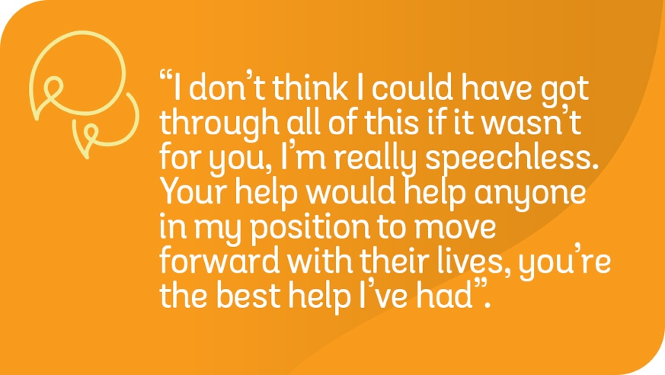

Supporting consumers to exercise their rights under the Mental Health Act
A 44-year-old woman with an adult child contacted the IMHA phone line to seek help. The woman was on a Temporary Treatment Order and seeking advocacy around treatment. She was unhappy with the medication she was prescribed, and that her treatment team had applied to the tribunal for an ECT hearing. The woman did not want to have ECT.
Service provided and outcomes
- Referral to VLA MHDL service for legal advice and representation at ECT hearing
- Coaching to Self-Advocate Advocate talked with consumer about advance statements, and provided the consumer with written information about advance statements
- Advocacy – Nurses were reluctant to witness the consumer’s advance statement so the Advocate explained that witnessing an advance statement does not mean that the witness agrees with the statement, only that they believe that the person making the statement understands what an advance statement is and the consequences of making the statement.
- Outcome – The treating psychiatrist, upon reading the advance statement, cancelled the ECT hearing, stating that the advance statement showed that the consumer had capacity to make decisions about their treatment. The consumer was discharged from hospital in the following week.
