IMHA Third-year report

Purpose
On 31 August 2018 IMHA turned three. The following is a summary of the service’s achievements, reflections and examples demonstrating individual and systemic advocacy. It also provides a brief overview of the independent evaluation of IMHA’s first three years undertaken by RMIT.

What is IMHA?
IMHA is a state-wide advocacy service for people receiving compulsory treatment under the Mental Health Act 2014 (Vic). IMHA is one of a range of mechanisms established to achieve the supported decision-making objectives of the Act.

Achievements
In its third year of operation IMHA focussed on consolidating and embedding the work done during the first two years (Click the following links to view the IMHA First year Report, Second Year Report and RMIT Evaluation Midterm Report). This has included continuing to provide services to consumers via a phone line staffed by advocates and delivering services in inpatient units across the state, as well as in the community; building on relationships already established with Designated Mental Health Services (DMHS), mental health support services, consumer led organisations, Office of the Public Advocate, Mental Health Complaints Commissioner and other services; promoting the service; developing consumer resources to support the implementation of supported decision making mechanisms under the Mental Health Act (2014) and providing supported decision making educations sessions to DMHS.
Building on the success of its first two years IMHA has continued to co-produce consumer information with our Senior Consumer Consultant and consumer advisory group – Speaking From Experience (SFE), including Advance Statement Guide and Template and Nominated Persons Guide and Template.
We are currently developing self-advocacy resources with consumers and SFE.
“I was treated with great respect and care and courtesy and I am truly grateful for the compassionate ear and overwhelmed by how quick I received a positive outcome… It was very much like being in a dark dungeon and now the lights are on, I have hope now thanks to the kindness of (IMHA Advocate). Thank you.” – IMHA Consumer
IMHA staff across the state are involved in a range of systemic advocacy activities including raising awareness about practices and trends within services and with the Department of Health and Human Services; attendance at Consumer Advisory Groups; delivering training to support capacity building across the mental health system; participation in Committees and Advisory groups; contributing to Victoria Legal Aid Policy and Law Reform submissions and research.
In January 2017, IMHA introduced a consumer survey provided to all consumers we work with and accessible on the website, to measure consumer satisfaction and impact. We continue to use this as an integral part of ensuring we get feedback from consumers. Approximately 75 consumer surveys have been completed to date.
Most consumers reported that they strongly agreed that:
- their IMHA advocate had listened to them, treated them with respect and supported them to communicate their views and preferences.
- their IMHA advocate effectively communicated with the treating team about their views and preferences, provided helpful information and linked them with helpful services
- they had a greater understanding of their rights, were more confident expressing their views and preferences.
SFE continues to meet and contribute to the work of IMHA and Victoria Legal Aid. In the last 12 months they have worked closely with IMHA to develop consumer Self Advocacy resources that will be available on our website and in DMHS in mid-2019. They have also worked with RMIT to support the external IMHA evaluation. SFE continue to participate in the recruitment of IMHA staff.

A Summary of the RMIT independent evaluation of our service
In May 2017 RMIT was appointed to undertake an external evaluation of IMHA’s efficiency, effectiveness and sustainability. The results of the midterm evaluation are available on the IMHA website and final evaluation results will be accessible in March 2019.
Overall the findings from the evaluation have been positive, from key stakeholders including consumers and clinicians. The results of the evaluation demonstrate that IMHA is delivering the service it is funded to deliver efficiently and effectively. The central tenet of IMHA’s service – rights based representational advocacy – was consistently demonstrated by the staff and valued by consumers.
Areas for further development were also identified, particularly regarding how IMHA could improve its reach and effectiveness, although strategies to achieve this will be impacted by the broader mental health system and by increasing IMHA’s resources. Recommendations were identified for the mental health system, IMHA and the Department of Health and Human Services. These included: IMHA operational improvements; resourcing requirements for advocacy to be available to all consumers who need it and changes that would allow automatic notification to IMHA of all consumers placed on compulsory treatment orders, as is the case in other jurisdictions.

A summary of our work
Below is a snapshot of IMHAs first three years’ achievements and information about consumers
who accessed services.

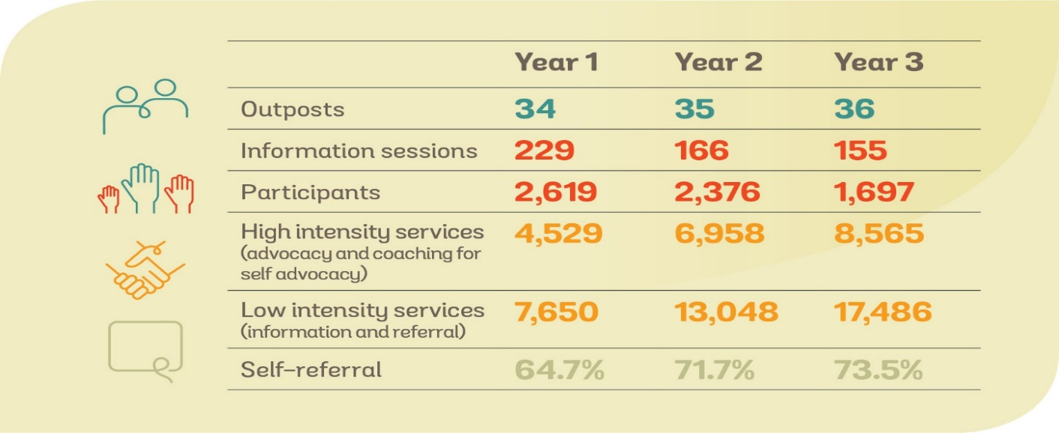

The following graphic provides demographic information about the consumers we provided a service
to in the first three years.

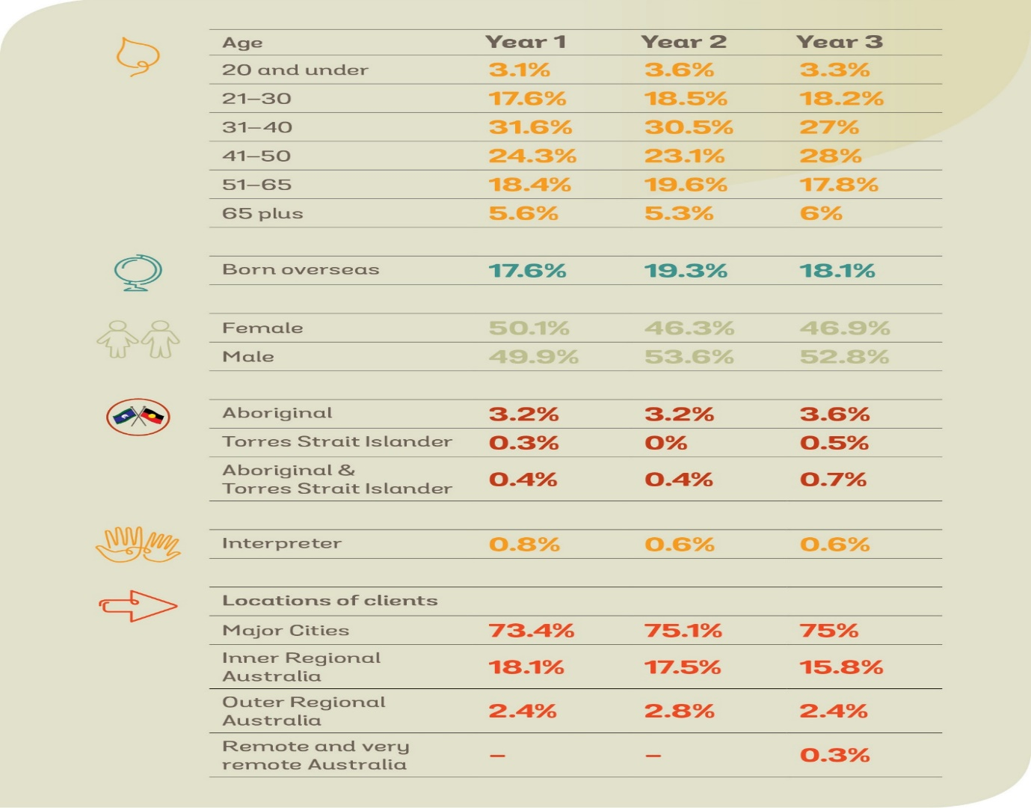

This year IMHA provided services to consumers who identified a range of concerns, advcoates provided a range of services including information, coaching for self-advocacy, advocacy and referral.

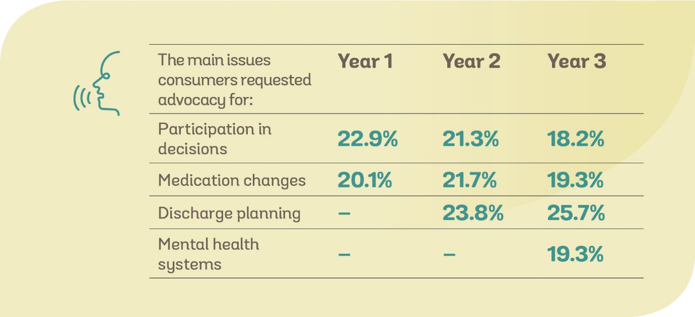

The following table provides details of the number of consumers advocates worked with in each DMHS in Year One, Year Two and Year Three. It demonstrates increasing demand for advocacy service across most DMHS. This data does not include all consumers who contact IMHA, such as those who only access our Phone Line.

Reflections from our first three years
The following are some of the trends that have been identified by IMHA advocates over the first, second and third years of service provision. Advocates from across the State log issues that arise in
the course of working with consumers, these are then reviewed and themed by the IMHA Manager.
The themes most frequently identified across the State are detailed below.
“Thank you to my advocate, I was able to get the help I needed, get on the right medication and be started back on the right track. She was very helpful, insightful and thorough with her advocacy with me and took my views and opinions into account the whole way through my treatment. I couldn’t have done it without her!” – IMHA Consumer
IMHA raises these issues with individual DMHS as well as with other relevant stakeholders, e.g. Office of the Chief Psychiatrist and DHHS. The trends remained similar in Years One and Two, as detailed below. During the Third Year there were some differences in trends and these are also detailed below:

Themes identified during the provision of individual advocacy in Years 1 and 2:

- Responses to family violence, sexual assault and childhood trauma in some services do not align with good practice as detailed in the Department’s Service Guideline on Gender Sensitivity and Safety and Guide on Identifying and Responding to Family Violence. For example, several consumers have told IMHA advocates they felt disclosures have been dismissed as part of their illness; some services have contacted perpetrators of violence to share information about the consumer despite the consumer’s disclosure of violence; and some consumers have had access to specialist services refused, e.g. sexual assault counsellors. Worryingly, several women have disclosed being discharged to housing where they will be unsafe due to family violence.
- Provision of information about rights – consumers often state that they do not know what Order they have been placed on, nor do they know what their rights are. This suggests consumers are not receiving copies of compulsory treatment orders and rights information is not provided in a way that supports consumers to understand them.
- Supported Decision Making appears not to be the decision-making model used across services, with Substituted and/or Shared Decision-Making being observed by Advocates as the most frequently used decision-making models. Indeed, most consumers requesting advocacy from IMHA are concerned they are not actively involved in their treatment, discharge planning, risk assessment or recovery, i.e. leave denied or restricted without the consumer’s involvement in decision making.
- Consumers’ physical health needs are often not addressed in a timely manner, for example, consumers are waiting for lengthy periods of time to see specialists.
There appears to be a general lack of access to talk therapies that may be preferred by consumers and a reliance on medication as the primary treatment modality.

Year 3:
- Access to consumers by advocates and Communication restrictions – this was frequently identified as hindering advocate and consumer access to advocacy services provided by IMHA usually because of restrictions placed on consumer use of mobiles; lack of privacy in communal areas where patient phones are located; and difficulty getting staff to assist with communication with consumers.
- Safety – this included consumers reporting use of force by security guards resulting in physical and emotional adverse impacts; and responses not aligned to DHHS Sexual Safety and Family Violence policies resulting in lack of support to consumers who have experienced sexual assault and/or family violence. This is consistent with Years One and Two.
- Rights – consumers frequently reported and advocates observed a disregard for people’s rights under the Mental Health Act, including people not being advised they are on an Order and if so how they meet the criteria for an order; coercion while a voluntary inpatient for instance being denied leave whilst voluntary; no provision of information about treatment plans; detention in acute units when not acute; and threatened with compulsory treatment if leave is requested.
- Leave – we have observed a standard approach to leave requests that does not consider individual needs and treatment and recovery plans; leave rules are not explained to consumers and then punitive responses are imposed when rules are breached; there is limited access to leave due to staff shortages.
Across all three years IMHA continues to observe that Supported Decision Making (SDM) mechanisms are not integrated into mental health service practice. Hence IMHA continue to roll out SDM training to services, with all DMHS agreeing to run these sessions. Results from the pilot SDM training pre and post evaluation demonstrate that the sessions significantly increased mental health staff knowledge and understanding of SDM mechanisms and their confidence to integrate these into practice.

How we make a difference
Angela’s Story
Angela (not her real name) is a single mum in her 40s who lives in Melbourne’s south-east.
In January Angela was struggling emotionally, as she ended a tumultuous and destabilising relationship. Her ex-partner, who had previously been violent to her was threatening and stalking
her. One day she told a friend she couldn’t cope anymore and went voluntarily to hospital, where
she thought she would be safe.
Angela had never been diagnosed with a mental health condition and was surprised to be made a compulsory patient at the hospital and told she could not leave. ‘I'd never been in the system before and I was just horrified. I mean my next of kin was my 21-year-old daughter and when they sent me to the (psychiatric ward) they didn’t even tell her.’
She found the experience of becoming a compulsory patient extremely distressing and confusing – 'They grabbed me by the ankles and proceeded to restrain me to the bed. They handed me two
pills and told me to take them and I said 'what's this and what are they for?' and they said 'you take them' and then they produced two big needles and said 'Look if you don't take them we'll inject you
with them.’
On the day she was admitted, IMHA Advocate Simon was giving a presentation to a group of consumers. As she waited to talk to a doctor, she listened in to Simon’s presentation and learned about IMHA’s role and how an advocate could help. At the end of the session she spoke to Simon and got his phone number.
The experience continued to be confusing and disempowering for Angela. ‘I hadn't even received a copy of my order after five days, so I didn’t know what was going on just that they were keeping me there and I should do what I was told’. Angela spoke to Simon over the phone and learned that she had the right to have a copy of her order and to have a say in her treatment and recovery.
Angela says the clinical team were unhelpful and dismissive of her concerns ‘… it didn't feel like I had support whatsoever except for IMHA. It was my saving grace. That was the only thing that kept me going, being reassured that I had rights. Because when you're within the system you're told to shut up and do as you're told because if you don't you won't get out and that was my fear, but having Simon and being able to speak to him was reassurance that I was going to be ok.’
Simon says he was pleased to help. ‘Working with Angela helped me understand how our service can work best. My role at the beginning was to provide support, information and advocacy during very difficult circumstances with the treating team.’
Eventually Angela used the techniques and information provided by Simon to get a copy of her order and use her rights under the Mental Health Act 2014 (Vic). She says IMHA’s reach needs to be extended so that all consumers can have access. ‘There needs to be an IMHA presence weekly or social workers in psychiatric wards. If you asked the nurses what was happening with your treatment and when you were seeing a Dr., they wouldn’t even answer you. So, you've got no one in there.’
According to Simon, Angela’s experience shows the value of IMHA and self-advocacy from consumers. ‘Throughout the process, Angela’s strengths shone through, and she increasingly took ownership of her advocacy. By the end of our time working together, Angela had the information and resources to assert her own rights.’
Since leaving hospital Angela has worked hard to step down off medication ‘I'm just about off it now, it's taken me a lot of work with my GP to get me off medication that I've never been on before and never had a need for.’ She’s back at home with her children, feeling safe and determined to help others. ‘There are people still inside the hospitals who don't even know they have any rights, they just do what they're told. I've always wanted to work in community services and this has given me a push now, so I've enrolled in a diploma of community service and would like to become an advocate for others in the system one day.’

